12.13: For convenience of calculation, recognize that the mass of the small sphere will cancel. The acceleration is then

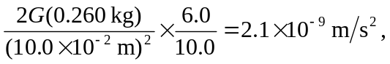

directed down.

